PROJECT TITLE : College Fees Checker

Project Introduction
The College Fee Checker project is a dynamic and user-centric web application developed to streamline the process of fee management and verification within educational institutions. Designed with both students and administrative staff in mind, this system offers a seamless platform for students to access detailed information about their tuition, hostel, and other associated fees securely and efficiently.
Objective
The primary objective of the College Fee Checker is to enhance the transparency and accessibility of fee-related information for students while simplifying the administrative tasks associated with fee management. By providing a centralized and automated solution, the application aims to reduce manual errors, save time, and improve the overall user experience for all stakeholders involved.
Technologies Used
- Frontend:
  - HTML5 & CSS3: Utilized for structuring and styling the web pages, ensuring a responsive and aesthetically pleasing user interface.
  - JavaScript: Implements interactive functionalities, enhancing user engagement and experience.
  - Google Fonts: Incorporated to provide modern and readable typography, contributing to a clean and professional design.
- Backend:
  - Node.js & Express.js: Serve as the foundation for the server-side operations, handling requests, responses, and business logic efficiently.
  - Microsoft SQL Server: Employed as the relational database management system to store and manage student data and fee details securely.
  - MSSQL Package: Facilitates seamless communication between the Node.js server and the SQL Server database.
  - dotenv: Manages environment variables, ensuring sensitive information like database credentials remains secure.
- Security & Performance:
  - CORS Middleware: Enables Cross-Origin Resource Sharing, allowing the frontend to communicate securely with the backend API.
  - Session Storage: Utilized for temporary data storage, enhancing security by ensuring session data is cleared upon browser closure.
Key Features
- Secure Authentication:
  - Students can log in using their unique Student Registration Number (SPR NO) and Date of Birth (DOB), ensuring that only authorized individuals access their fee information.
- Comprehensive Fee Breakdown:
  - Upon successful authentication, students can view a detailed breakdown of their fees, including hostel fees, tuition fees, textbook fees, skill development fees, exam stationery fees, and notebook fees.
- Responsive Design:
  - The application is designed to be fully responsive, providing an optimal viewing experience across various devices, including desktops, tablets, and smartphones.
- User-Friendly Interface:
  - A clean and intuitive user interface ensures that students can navigate the application effortlessly, accessing the information they need without unnecessary complexity.
- Error Handling:
  - Robust error handling mechanisms inform users of any issues during login or data retrieval, enhancing the reliability and trustworthiness of the application.
Benefits
- Efficiency: Automates the fee management process, reducing the time and effort required by administrative staff and eliminating the need for manual data handling.
- Accuracy: Minimizes human errors associated with manual fee calculations and record-keeping, ensuring that students receive precise and up-to-date fee information.
- Transparency: Provides students with clear visibility into their financial obligations, fostering trust and accountability within the educational institution.
- Scalability: Built with scalability in mind, the application can accommodate an increasing number of users and additional features as needed, ensuring long-term viability.
Conclusion
The College Fee Checker project embodies a modern solution to traditional fee management challenges faced by educational institutions. By leveraging cutting-edge web technologies and a robust backend infrastructure, the application delivers a secure, efficient, and user-friendly platform that significantly enhances the fee management experience for both students and administrators. As educational environments continue to evolve, tools like the College Fee Checker play a crucial role in fostering operational excellence and student satisfaction.
PROGRAM:
1)Login.js
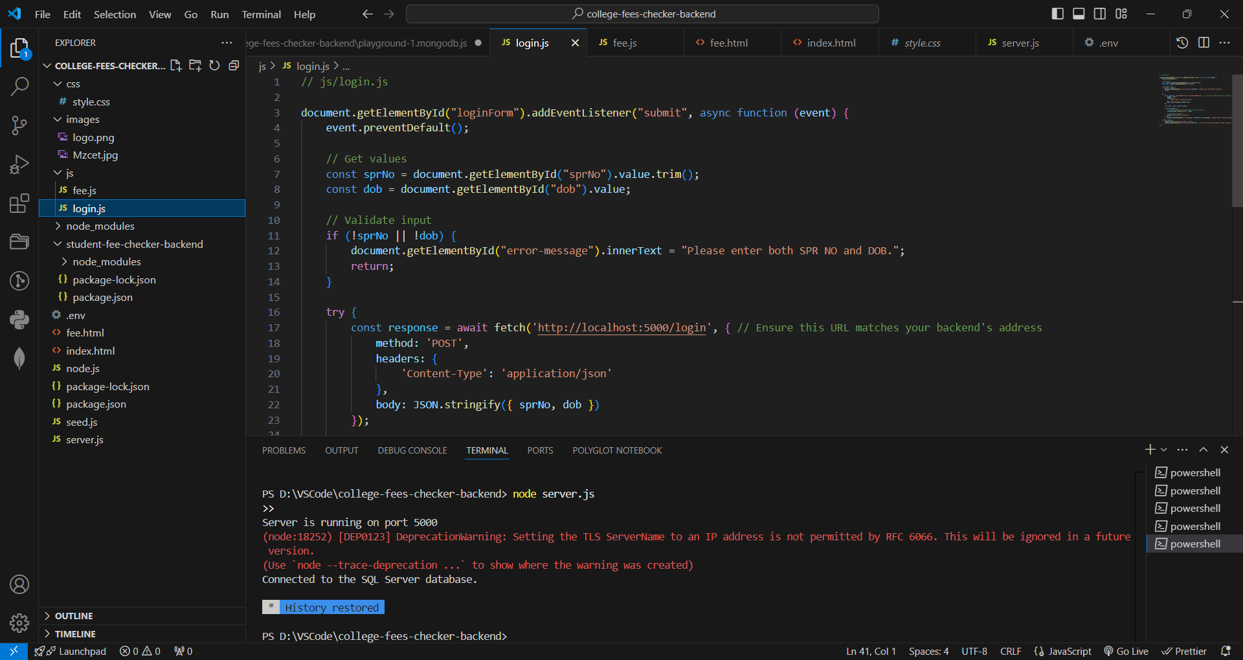

2)fee.html
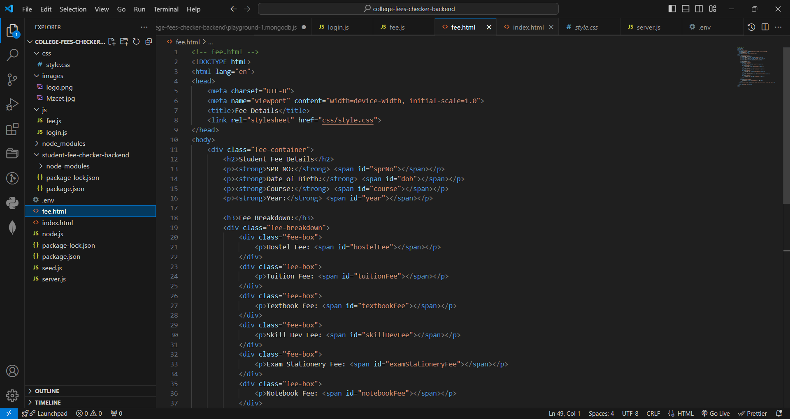
3).env
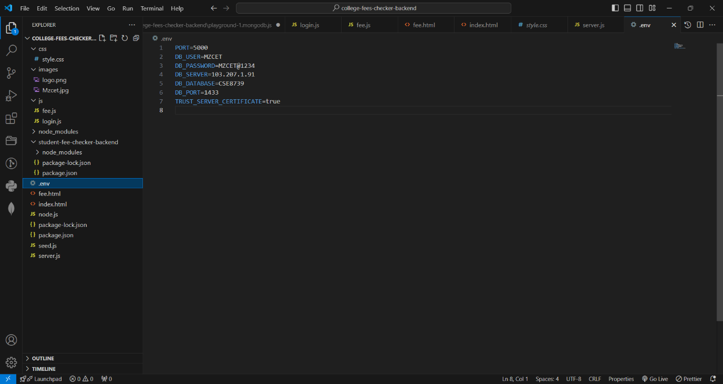

4)node.js
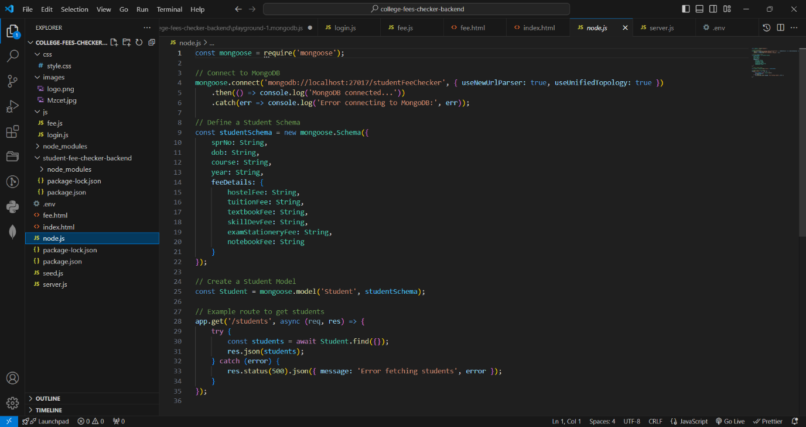

5)index.html
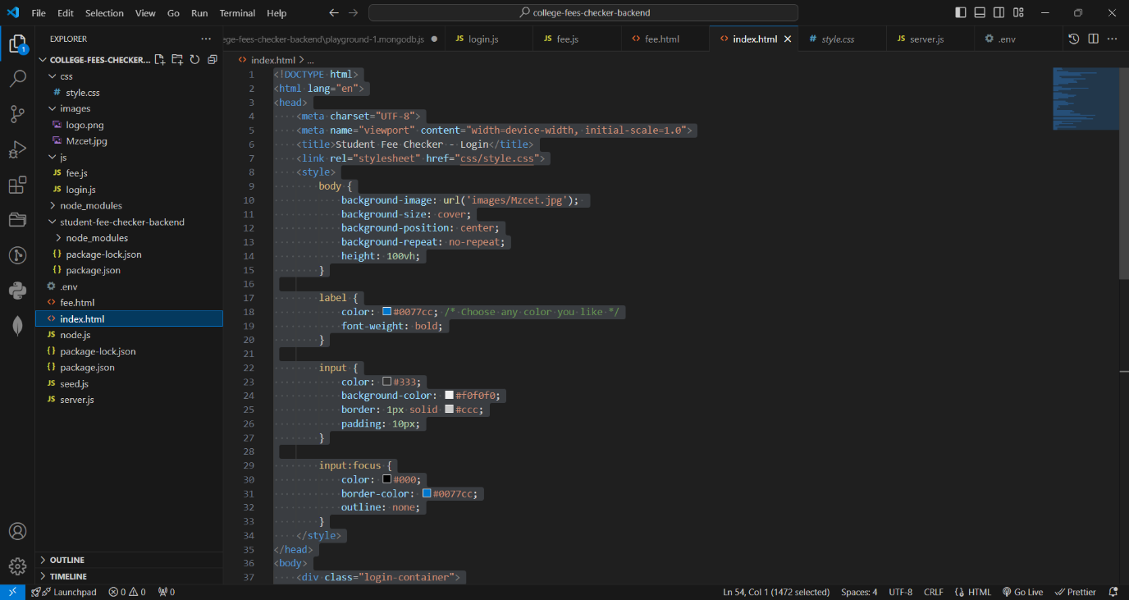

6)style.css
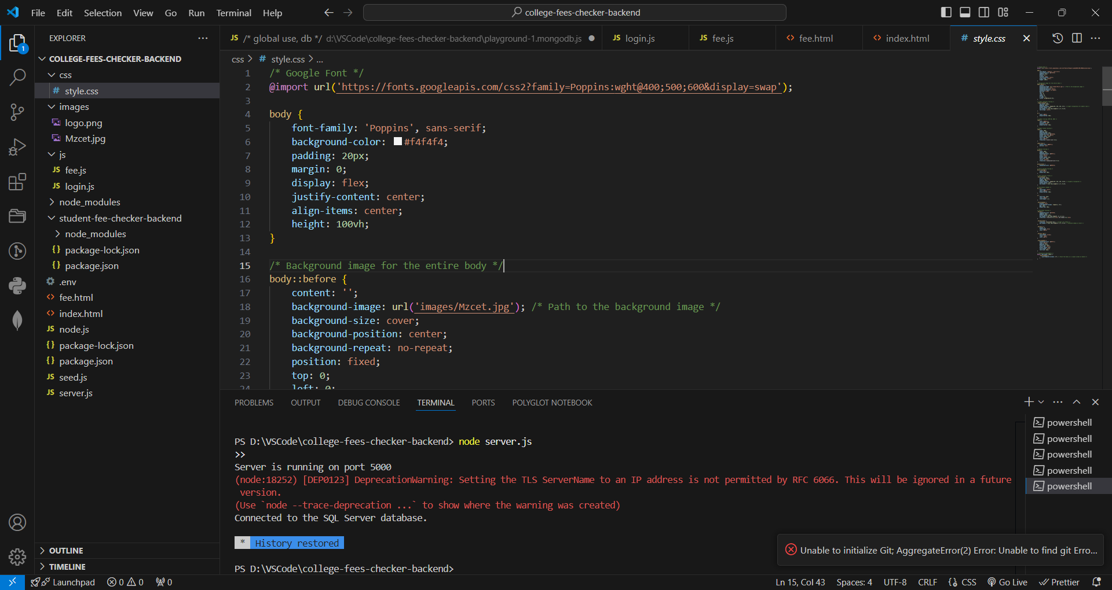

7)server.js
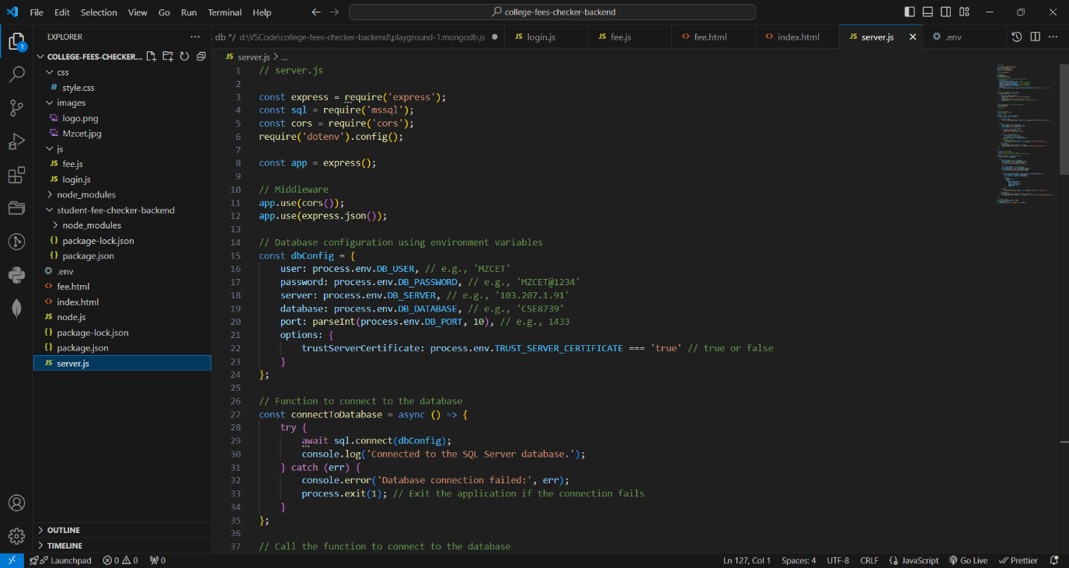

8)fee.js
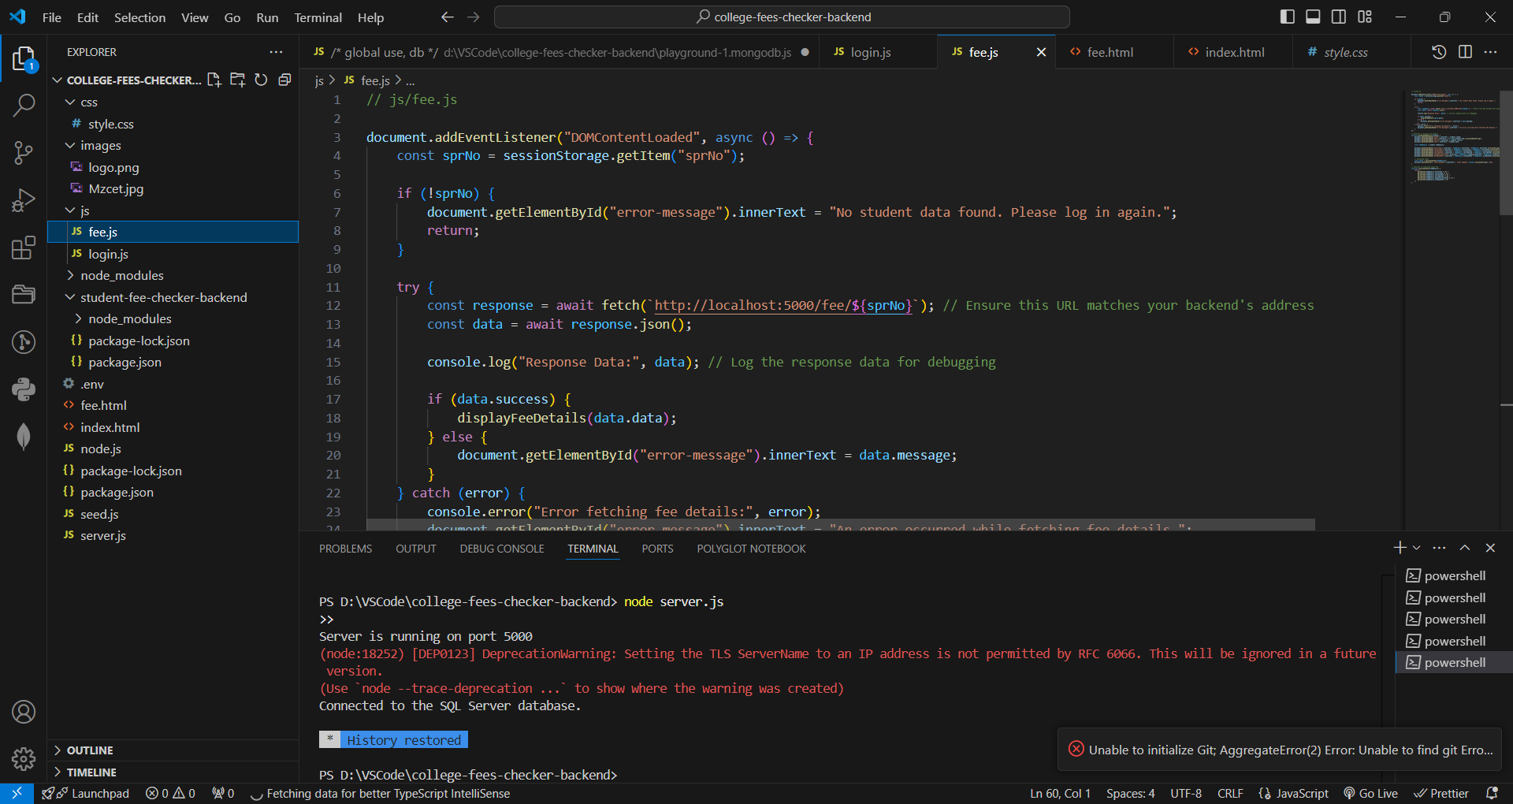
DATABASE:
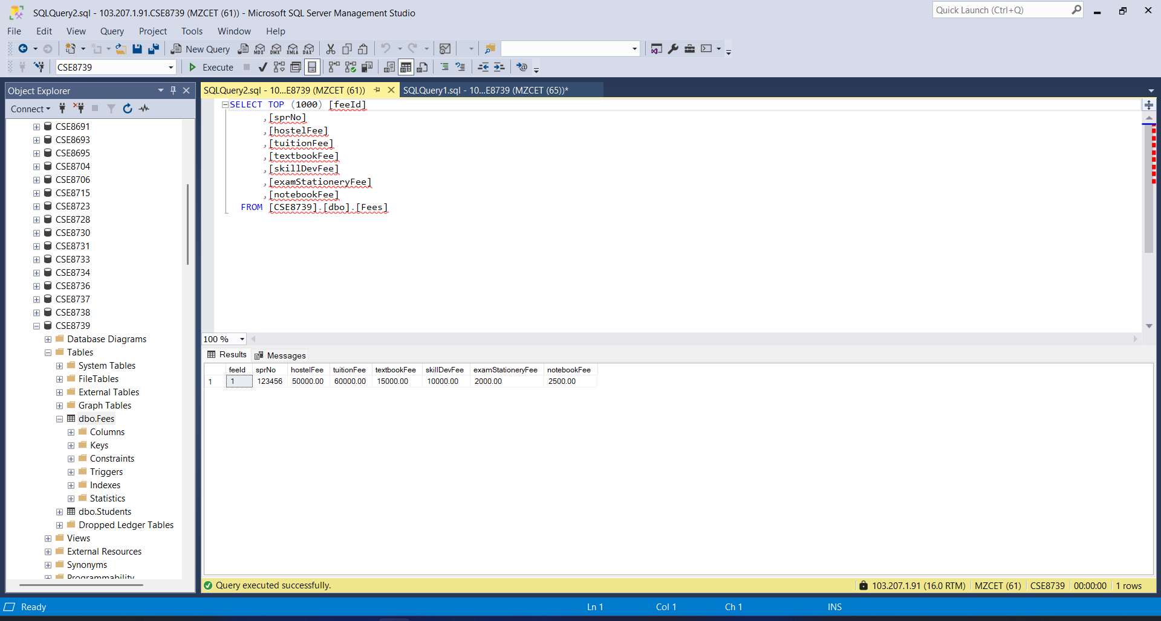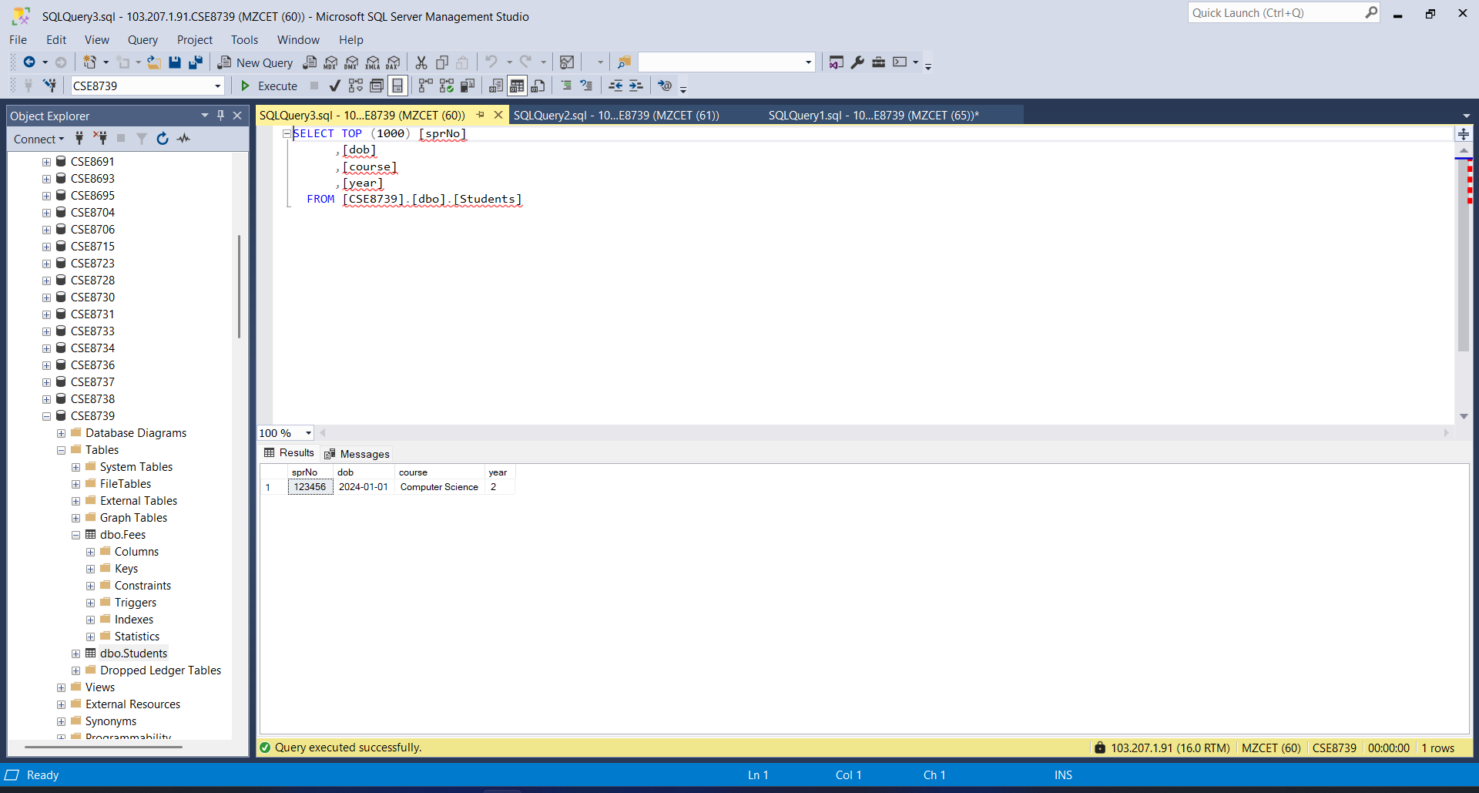

OUTPUT: 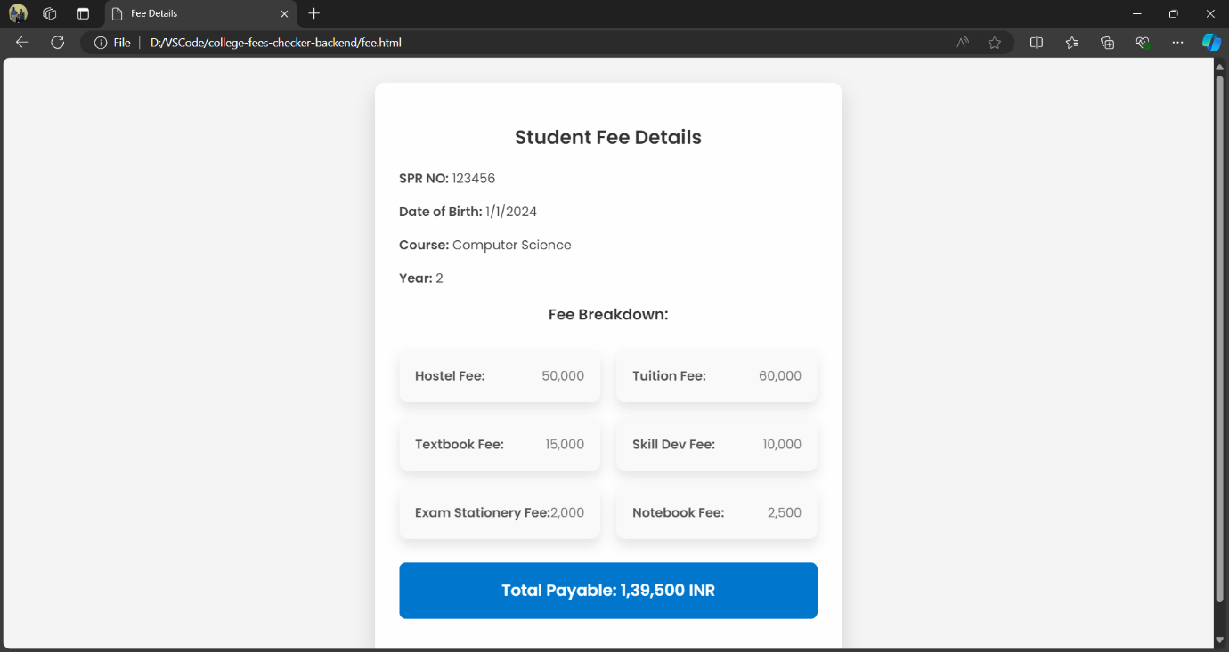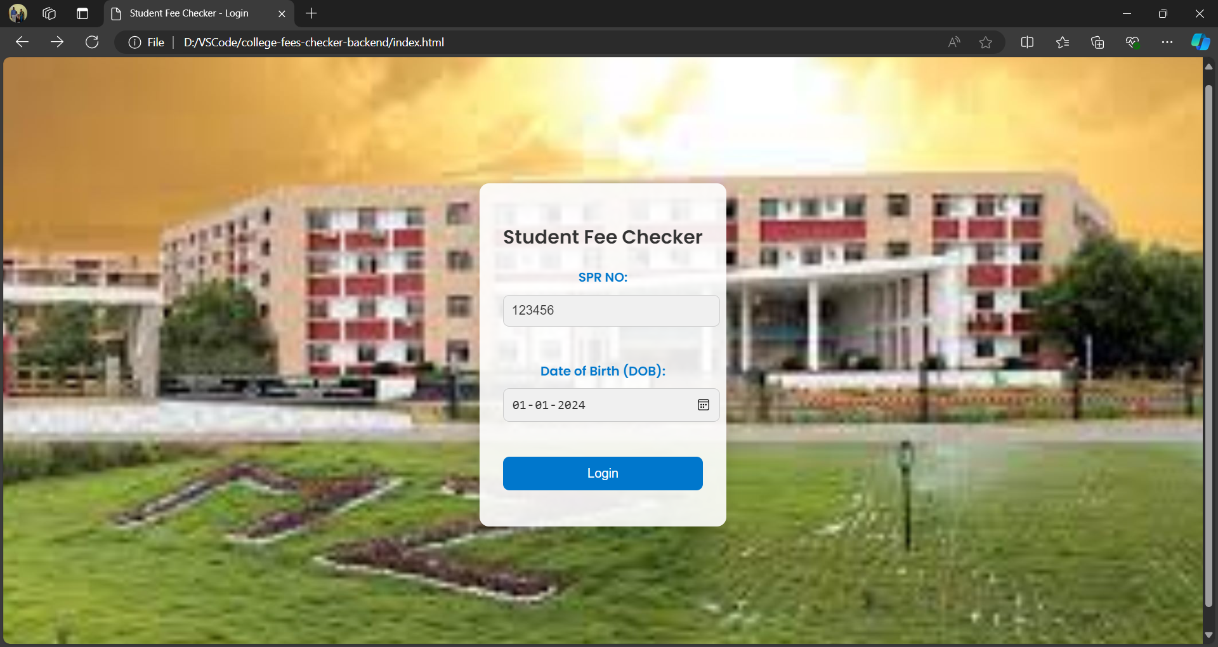 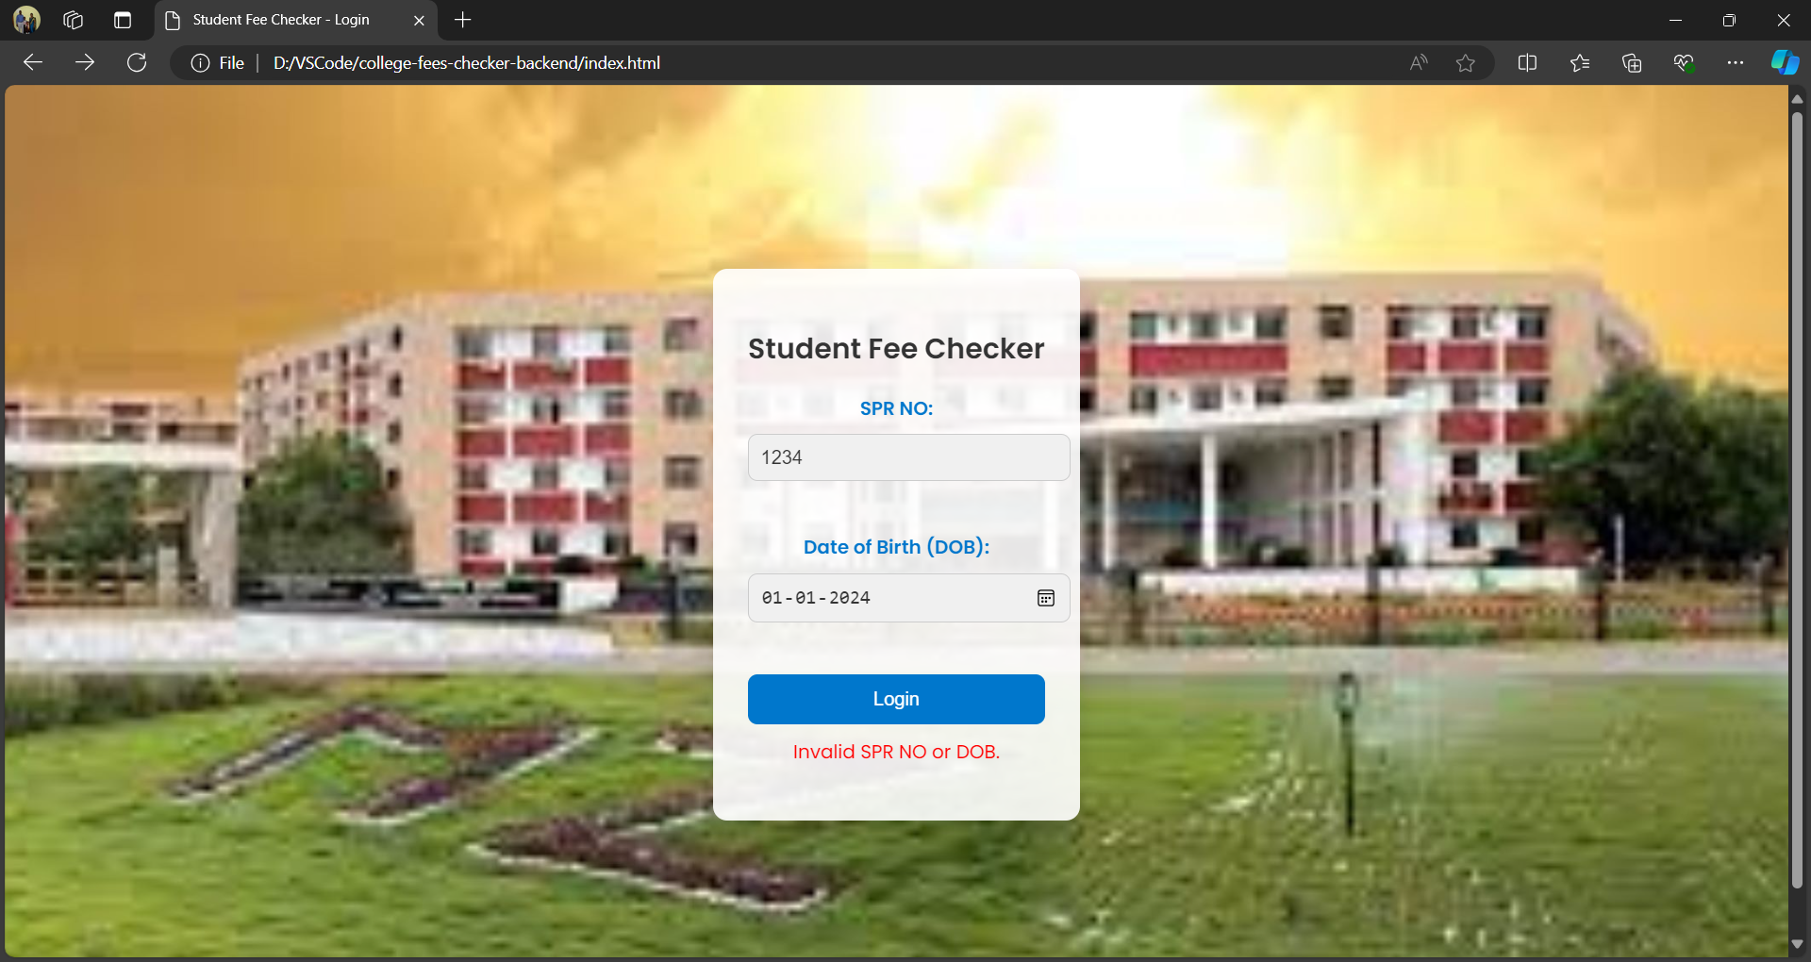

TEAM MEMBERS:
PAULSON J – 8739
NAVEEN C - 9087

